REALIZING THE AGING-IN-PLACE SENIOR COMMUNITY
REVERIE AT SILVER CREEK

As the year 2011 began on January 1st, the oldest members of the Baby Boom generation celebrated their 65th birthday. In fact, for every day for the next 19 years, 10,000 baby boomers will reach age 65. The aging of this huge cohort of Americans (26% of the total U.S. population are Baby Boomers) will dramatically change the composition of the country. Currently, just 13% of Americans are ages 65 and older. By 2030, when all members of the Baby Boom generation have reached that age, fully 18% of the nation will be at least that age, according to Pew Research Center population projections.
A recent survey conducted by the American Association of Retired Persons (AARP) found that over 90% of seniors age 65 and older want to remain in their own homes indefinitely..... "The idea of all these projects is to make it easier to spend another ten years in the home, but not make it feel institutional". According to the Freedonia Group, "Aging-In-Place" is the fastest growing sector of the senior care industry. The National Association of Home Builders predicts that aging-in-place for remodeling homes alone, represents a market of $20-$25 billion.

When asked, seniors express the following desires for how they would prefer to live, with-

- Independence-seniors would choose not to live with their children or relatives but to maintain control over how they spend their time, what they chose to eat and what activities they select
- Society-they do not want to live isolated in a large building or complex remote from services. They want most of all to live in a neighborhood, where if they choose, they can socialize with those living close by. Most importantly, they want to be able to have their children, friends and grand-children be able to visit and stay over
- Transportation-access to their own vehicle if appropriate and to mobility services when needed.
- Security-they want the peace of mind to know that their neighbors are available to look out for the welfare of each other particularly should anything happen. They want to be comfortable in their neighborhood, not just outside, but also inside their own home.
- Access to Assistance-they and their children know that physically they are not as active or as alert as they may have been. They want someone they can trust to help with basic household chores and for those who have some chronic condition to have assistance with bathing, shopping and managing medications from a reliable source
- Communication-they rely increasingly on the internet to communicate with family and friends and want access to reasonably priced internet access.

Synthesis Interests is developing a senior community which incorporates essential pragmatic responses to these desires, realizing the opportunity and choice for its residents to age-in-place in their homes. There are five basic elements as shown below:
COMMUNITY

ACCESS TO HOME CARE
UNIVERSAL DESIGN FEATURES
SECURITY
CONNECTION

PROVIDING A REAL SENSE OF COMMUNITY
OPPORTUNITIES FOR SOCIALIZATION

The importance of social interaction to the physical and mental health of seniors has been well documented. Providing such opportunities is one of the major principles upon which the Reverie at Silver Creek’s community plan has been based. The community plan is shown below with the key elements indicated.

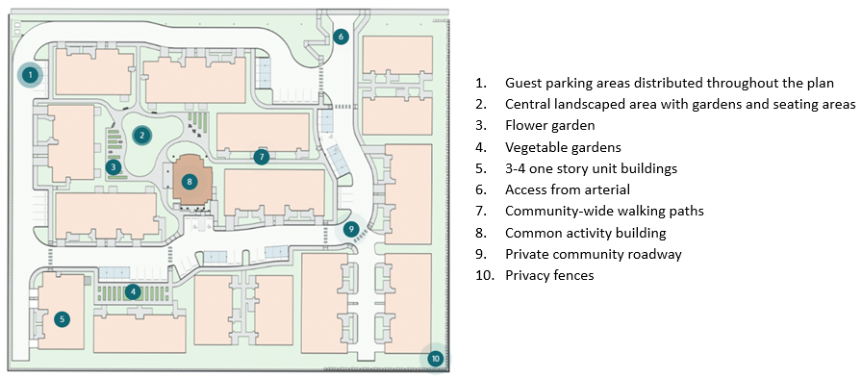

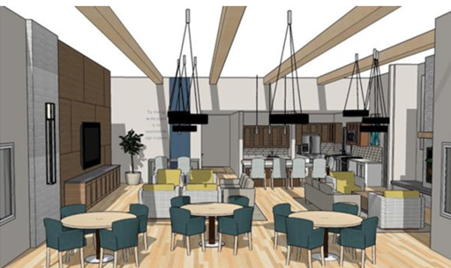

The Centrally Located Common Activity Building, functioning as a gathering place with the opportunity for residents to organize and participate in events and presentations by invited speakers coordinated by the on-site community manager.

The exercise room with equipment and an outdoor patio for classes.

Paved walking paths continuous throughout the community with connection to the sidewalk along the public road and shaded stopping places. Bollard lighting installed to enable its use evenings.

Flower and vegetable gardens at multiple locations in the community.

ATTENTION TO DETAIL-PLANNING AHEAD FOR CHANGE

This term, Aging-in-Place is most often associated with independence. In reality, it cannot be realized in isolation. It needs a network of support from transportation, formal and informal home care, increasingly technology and most importantly, homes and community settings designed to recognize and anticipate the physical and emotional aspects of aging. Certain of these changes include:

- Poorer eyesight
- Reduced muscle mass and hece less strength
- Diminished endurance both physical and mental
- Higher risk of accidents due to bone fragility and less balance when walking
- Reduced hearing capacity
- Diminished mobility and agility
- Decreased flexibility
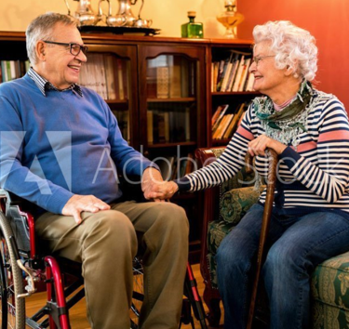 In response, working with a nationally recognized expert, the homes have been designed with built-in features to anticipate and accommodate these changes. Each with over sixty “Universal Design” features to help better perform daily tasks while maintaining a high degree of independence carefully arranged for convenience and safety. Such features are present in all aspects of the design of the residences.
The floor plans for three, of the five-unit types, are shown below. 60% of the residences have an attached one car garage, with the remainder having reserved carports close to their residence. All have private patios. All spaces throughout are ADA compliant with wide corridors, special lighting, light weight doors and lever handles together with color selections for walls, doors and floor treatments to help avoid falls.
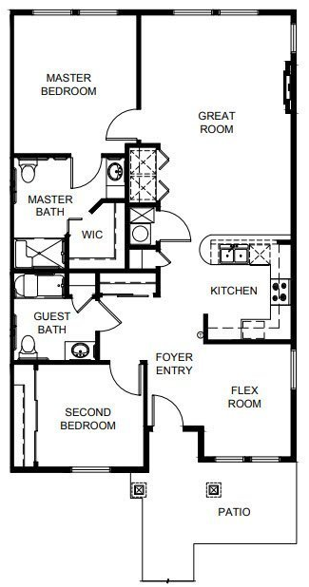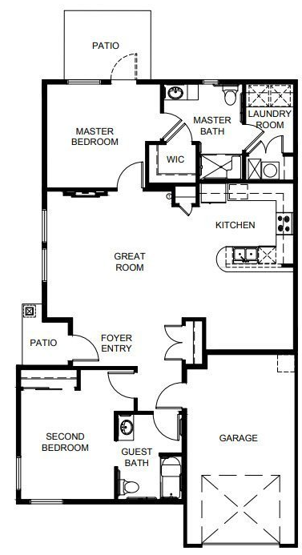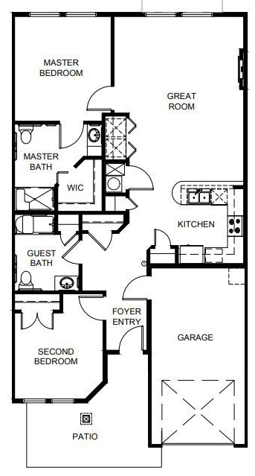
The attention to detail in the features included in the residences are illustrated by the examples which follow for the kitchens and bathrooms.
for Kitchens
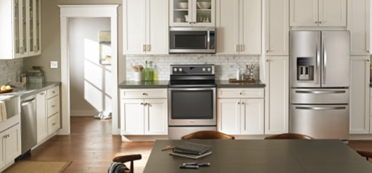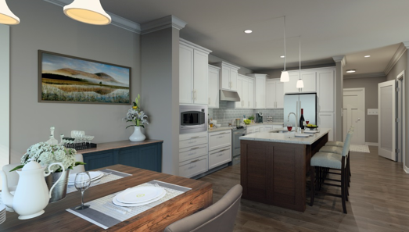
- U Shaped with room to maneuver
- Counter space on both sides of the cook-top and stove
- Cabinets and pantry with full-depth pull-out draws and shelves
- Energy efficient glare free lighting
- Rounded corner countertops
- Moderate depth sink with single lever faucet
- Elevated dishwasher
- Easy to read and operate appliance controls

for Bathrooms
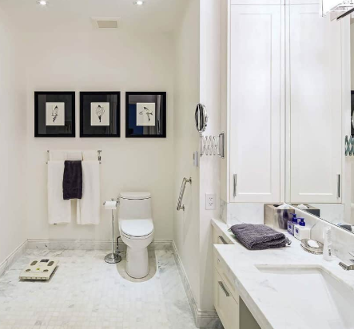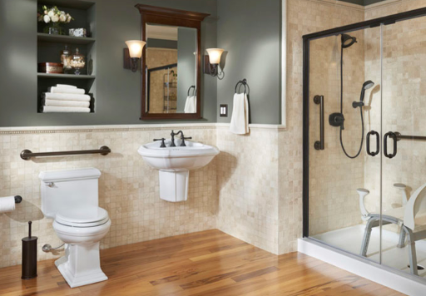
- Easy to clean slip resistant floors
- Curb-less shower with flexible hose spray
- Mirror and vanity at a height that can be used while seated
- Large oval sink with single lever faucet
- Heavy duty towel bars

PERSONALIZED ASSISTANCE WHEN NEEDED
Pre-screened local home care and home health care providers with the residents able to select from these or other providers coordinated by on-site community manager
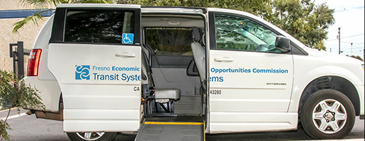
Van service provided several times each week for individual or group trips for shopping, entertainment, health and wellness or other excursions

TECHNOLOGY ENABLED CONNECTION TO FAMILY & FRIENDS
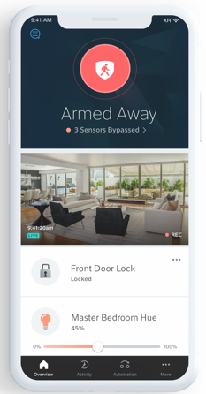
High speed internet provided for all residences
Optional fall monitoring and call technology choices
On-line Reverie at Silvr Creek Community

PEACE OF MIND-PROVIDING FOR SECURITY
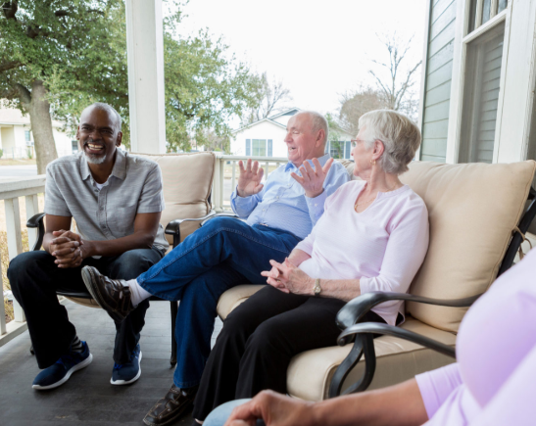

Security cameras located along the private interior roadway
Single vehiclular entry from the arterial
Privacy fence along the property boundaries
Optional home security system internet enabled
Neighbors next door
The Reverie at Silver Creek residences and community building are under construction with the first group of residences to be competd within four to six months. An extensive outreach and marketing program is being undertaken, enabling on-line and person to person contact with both prospective residents and organizations providing services to seniors.

