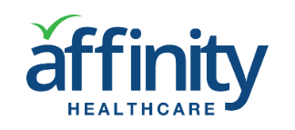
APPLICATIONS FOR HOME CARE AND HOME HEALTH CARE
Synthesis Interests Inc., Affinity Healthcare division in partnership with Chesterfield Services Inc. one of the largest private home care and home health care company in the Washington State, have developed a suite of software applications to address fundamental problems in the home care and home health care industry to:
- Enable on-going real-time feedback from clients, caregivers and case managers to identify issues and problems and document actions taken
- Increase transparency and accountability in caregiver management and quality of service delivery
- Reduce the need for on-site training for caregivers
- Allow supervisors to create and implement self-directed caregiver training tailored to particular client conditions and service needs
- Help to improve quality of client care by providing enhanced caregiver knowledge and competence
- Provide caregivers anytime access to best practices and solutions to common problems to avoid client and caregiver injury and litigation
The AFFINITY platform has four main integrated feature areas as shown below.
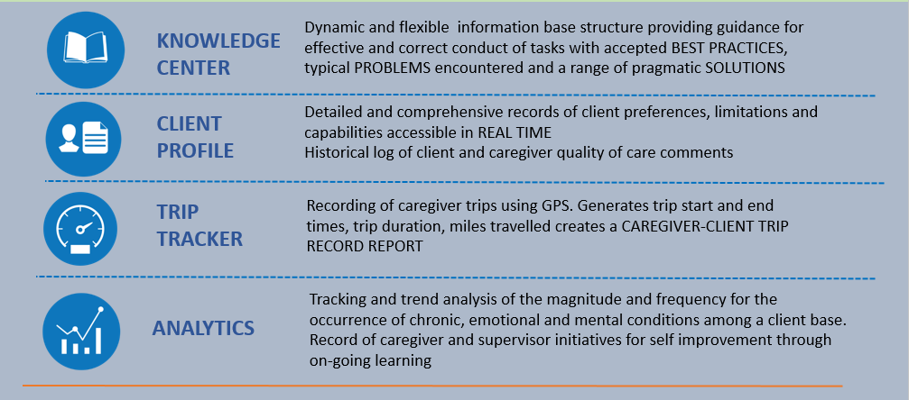
Affinity’s KNOWLEDGE CENTER contains detailed descriptions of best practices as to how effectively to deliver specific tasks and subtasks, such as bed bath or medication management. It provides guidance as to efficiently sequence and organize assigned tasks. It identifies typical problems, before they are encountered by caregivers together with pragmatic solutions. It is designed to be a dynamic flexible information base that can be tailored to accept a wide range of content.
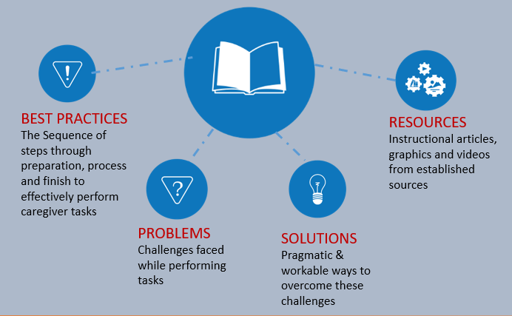
Typically, prior to any client contact, several weeks of training is provided to potential caregivers with periodic continuing education. This training does not equip the caregiver to deal with actual issues they encounter in the field related to particular client needs and limitations nor does it provide them with the best ways to address these issues.
What is currently lacking, is what can be termed “client centered learning”. Affinity’s LEARNING GUIDE provides this focused link between the client/caregiver and information contained in the Knowledge Center.
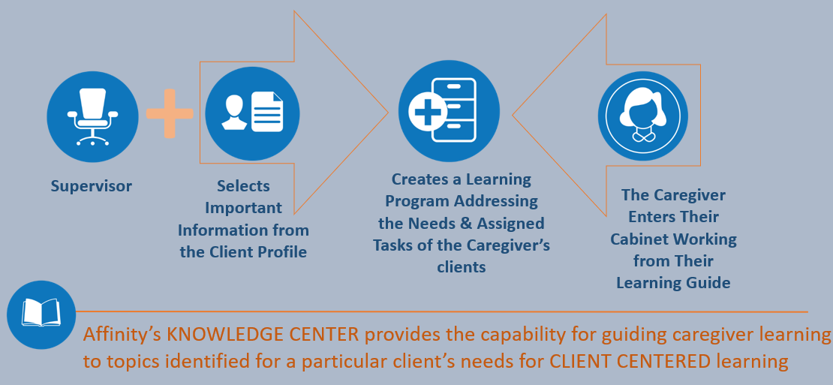
Supervisors or case managers, selecting information from Affinity’s digital CLIENT PROFILE, can create a learning pathway for the caregiver. This directs them to information appropriate to their particular client’s conditions and authorized tasks.
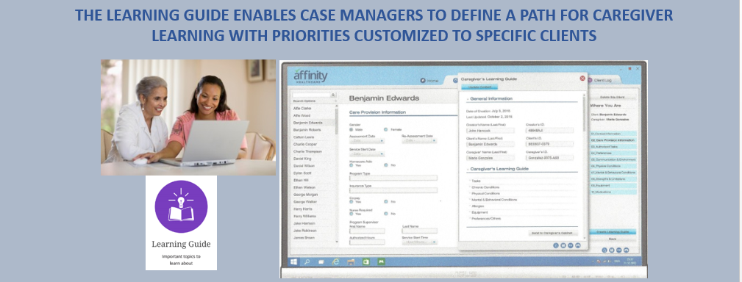
Affinity enables clients and caregivers to send date stamped comments anytime which express changes in client conditions or preferences and the level of satisfaction with the caregiver’s service delivery. Supervisor’s responses can then be sent back to the client or caregiver and saved within the secure CLIENT’S CABINET.
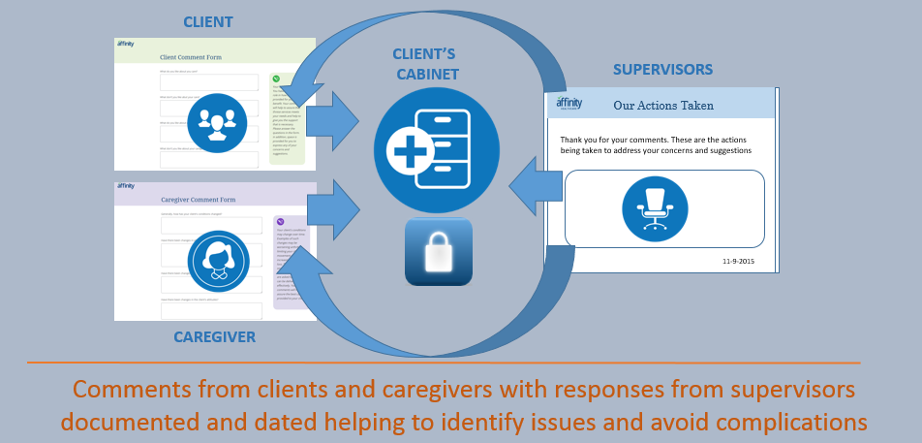
The most prevalent means whereby it can be confirmed when a caregiver arrives and leaves from a client’s residence is by the use of the client’s phone. This call is then typically logged using an automated system. However, there is no means to assure that the caregiver is indeed present for the required duration of any service day. Caregiver “windshield” time and mileage can be reimbursed. Affinity’s TRIP TRACKER provides a detailed record for all caregiver trips and their duration including those taken on behalf of the client to their physician or for shopping.
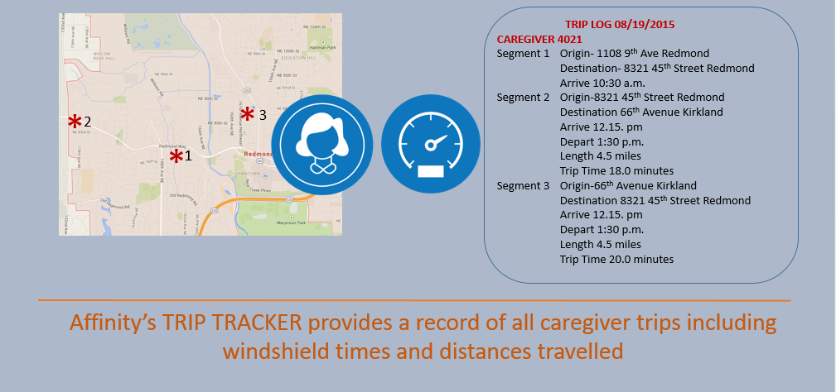
Affinity’s ANALYTICS tracks each user’s inquiry into the knowledge center by subject matter and the duration and time for that viewing. This can be applied to assure that caregiver’s Learning Guide assignments are indeed completed. It also defines which content in the Knowledge Center is most viewed and therefore may need to be enhanced.
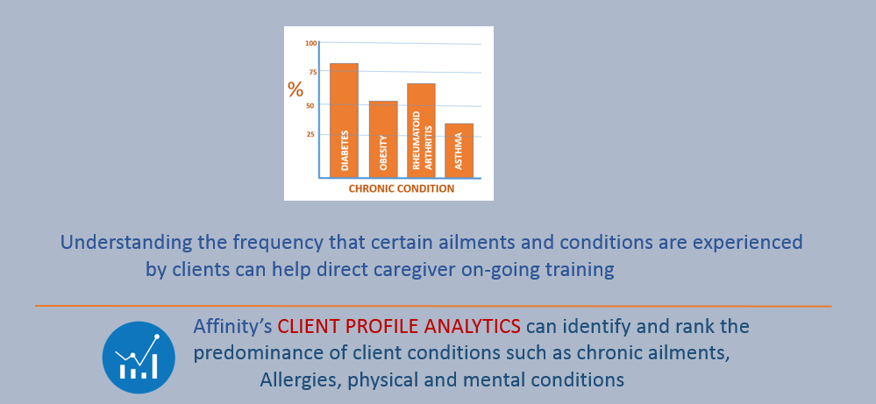

The Affinty Healthcare platform has been designed with the direct participation of caregivers, supervisors and managers who are involved day to day with addressing ways to improve caregiver performance and the quality of care provided to their clients.

